Project Design Phase-II
Technology Stack (Architecture & Stack)

Date | 19 February 2026
Team ID | LTVIP2026TMIDS77295
Project Name | Smart Sorting: Transfer Learning for Identifying Rotten Fruits and Vegetables

Technical Architecture:
The Deliverable shall include the architectural diagram as below and the information as per the table1 & table 2
Example: “Smart Sorting: Transfer Learning for Identifying Rotten Fruits and Vegetables”.
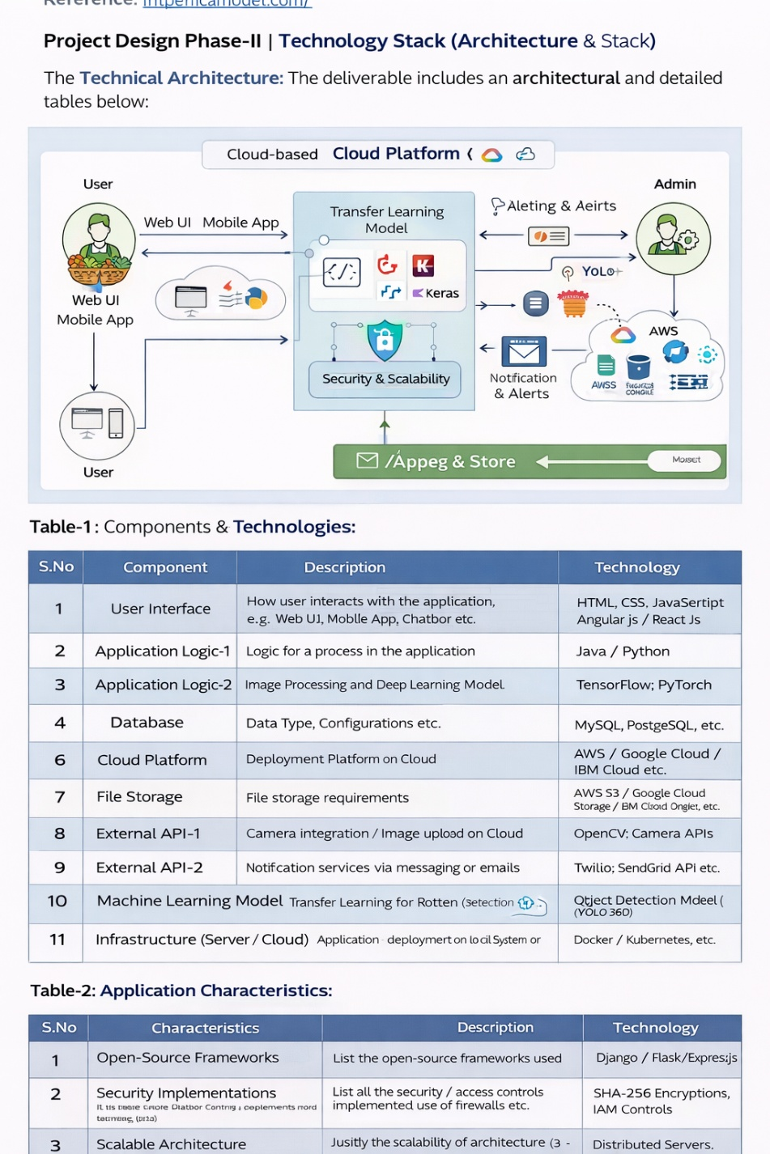
Project Flow
1. User Access and Navigation
- The user opens a browser and visits the application URL (e.g., http://127.0.0.1:5000/).
- The Home page loads, showing the project title, brief description, and navigation menu (Home, About, Predict, Contact).
- From the navbar, the user can move to:
  - About – to read about the model and metrics.
  - Predict – to perform fruit/vegetable freshness prediction.
  - Contact – to view team and contact details.

2. Dataset and Model Preparation (Offline Flow)
- Images of fresh and rotten fruits/vegetables are collected, cleaned, and organized into labeled folders (Fresh, Rotten). Similar workflows are used in fruit quality projects.
- The dataset is split into training and testing sets and loaded using data generators.
- A MobileNetV2-based model is built using TensorFlow/Keras, with a custom classification head for Fresh vs Rotten.
- The model is trained, evaluated (accuracy, confusion matrix, F1-score), and the best weights are saved to a file such as model/healthy_vs_rotten.h5.
- This trained model file is then used by the Flask app during runtime for predictions, so training does not happen every time the app runs.

3. Prediction Flow (End-to-End Runtime)
- The user clicks on the Predict menu item to open the prediction page.
- On the Predict page, the user:
  - Clicks “Choose File” / “Browse”.
  - Selects an image of a fruit or vegetable from their device.
  - Clicks the Predict / Upload button.
- The browser sends a POST request to the /predict route of the Flask server with the image file attached.
- In the Flask backend:
  - The server checks if a file has been uploaded and whether its extension is allowed (e.g., .jpg, .png).
  - The image is saved temporarily in the uploads/ directory.
  - The saved image path is passed to a prediction function (e.g., in predict.py).
- In the prediction function:
  - The image is opened and preprocessed (resize to target size such as 224×224, convert to RGB, normalize pixels) to match the MobileNetV2 input format.
  - The preprocessed image is fed into the loaded model (healthy_vs_rotten.h5).
  - The model outputs a probability score; this is converted into:
    - Predicted class: Fresh or Rotten.
    - Confidence percentage (e.g., 92.3%).
- The prediction result (label and confidence) and the image path are returned to Flask and passed to the Result template.
- The Result page is rendered, showing:
  - The uploaded image.
  - The predicted label (Fresh/Rotten).
  - The confidence score.
  - Optional message (e.g., “This fruit is likely fresh with high confidence”).

4. About and Contact Flow
- When the user clicks About, Flask serves a page that explains:
  - Project idea and purpose.
  - Technologies used (Flask, TensorFlow, MobileNetV2, etc.).
  - Model performance metrics (accuracy, dataset size, classes).
- When the user clicks Contact, the Contact page shows:
  - Team member names and roles.
  - Project/college identifiers or contact information.

5. Error Handling Flow
- If the user submits the Predict form without selecting an image, Flask detects the missing file and:
  - Does not call the model.
  - Returns the Predict page again with a clear error message (e.g., “Please upload an image”).
- If the user uploads an invalid file type:
  - The backend checks the extension and rejects the file.
  - A friendly error message is shown instead of a server crash.

6. Optional Future Flow (Extension)
You can also mention how the flow would extend in future:
- Store each prediction (image path, result, timestamp) in a database for history and analytics.
- Add user login so only authorized users can access prediction or admin pages.
- Deploy the Flask app to a cloud platform so external systems or mobile apps can call the prediction API. Similar deployments are shown in other Flask + MobileNetV2 applications.

Table-1 : Components & Technologies:
S.No | Component | Description | Technology
 | User Interface | Web UI where user opens Home, About, Predict, Contact and uploads fruit/vegetable images. | HTML5, CSS3, JavaScript, Jinja2 templates (Flask).
 | Application Logic-1 | Web application backend handling routing (/, /about, /predict, /contact) and form handling. | Python 3, Flask web framework.
 | Application Logic-2 | Image upload logic: validation, saving file to uploads/, building URL for result page. | Python (Flask request, send_from_directory, os)
 | Application Logic-3 | Prediction logic: calling predict_image(), preprocessing image, passing to model, mapping to label. | Python (TensorFlow/Keras, NumPy, tensorflow.keras.image).
 | Database | (Optional/Planned) Store prediction history, image path, timestamp, label and confidence. | SQLite or MySQL (simple relational schema).
 | Cloud Database | If deployed to cloud and history needed, same schema hosted as managed DB. | MySQL on cloud / PostgreSQL on Render/Heroku.
 | File Storage | Store uploaded test images and trained model file. | Local filesystem: /uploads/, /model/healthy_vs_rotten.h5
 | External API-1 | (Planned) Email/contact integration for feedback or alerts. | SMTP email API / Gmail SMTP.
 | External API-2 | (Optional future) Cloud storage or monitoring API if app is deployed at scale. | AWS S3 / GCP Storage / logging API.
 | Machine Learning Model | Binary classifier to detect Fresh vs Rotten using transfer learning. | MobileNetV2 base (ImageNet weights) + custom dense head (Keras).
 | Infrastructure (Server / Cloud) | Deployment environment hosting Flask app, model, and static files. | L Local machine (development) and optional cloud VM / PaaS (e.g., Render/Heroku).

Table-2: Application Characteristics:
S.No | Characteristics | Description | Technology
 | Open-Source Frameworks | Core stack is built completely on open-source libraries and tools. | Flask, TensorFlow/Keras, NumPy, Bootstrap/FontAwesome, Python 3.
 | Security Implementations | Basic security: server-side validation of uploads, limit to image types, hide model path, no direct directory listing. | Flask send_from_directory, file type checks, app-level access control, HTTPS when deployed.
 | Scalable Architecture | Three-layer style: UI (templates) → Flask API layer → ML model layer; can be separated into micro-services later if needed. | 3-tier web architecture on Python/WSGI; model callable as separate service in future.
 | Availability | In dev: single Flask instance; in production can run behind a WSGI server with multiple workers and health checks. | Gunicorn/uWSGI, Nginx reverse proxy (when deployed).
 | Performance | Pre-loaded model in memory; images resized to 224×224; lightweight MobileNetV2 for fast inference (< few seconds per image). | TensorFlow/Keras optimization, caching model at startup, using GPU/CPU acceleration if available.
 | Usability | Simple navigation (Home, About, Predict, Contact), responsive layout, dark/light theme toggle. | CSS, responsive design, minimal clicks to predict.
 | Maintainability | Clear separation into scripts (split_dataset.py, train.py, predict.py, app.py) and templates/static assets. | Modular Python packages, template inheritance in Flask.
 | Portability | Runs on any OS with Python; can be containerized and deployed on different clouds. | Python virtual env, Docker (optional).

